SCENARIO:

The document outlines the requirements for a network routing assignment focused on designing and justifying a new network for FinTec Inc company addressing the problem they are facing e.g, efficiency, security, and resilience. It details the topology requirements, including site connections, VLAN setup, and routing protocols, emphasizing the necessity for testing and documentation. The deliverable is a technical report aimed at board members, explaining each technology's rationale and effectiveness.

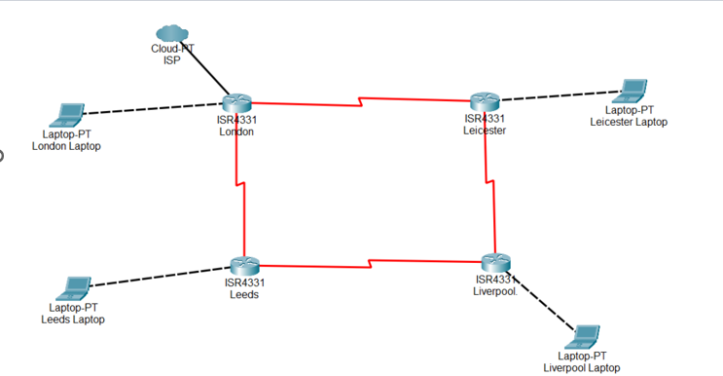
Figure 1: FinTech Inc Network Topology

The Topology detail
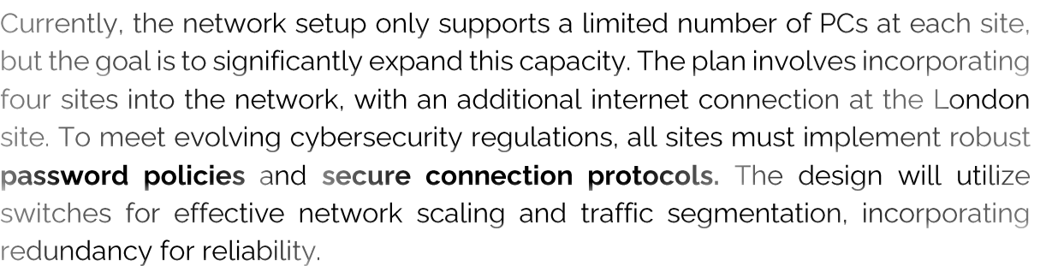

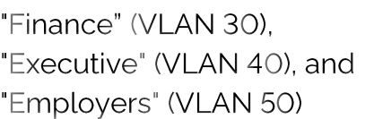

•

•

•
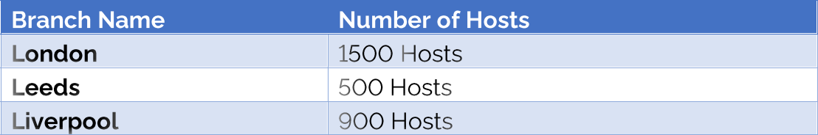

Each site is required to implement a routing protocol, which must be carefully selected and operational. Given historical issues with service interruptions, the company seeks a resilient network solution that remains functional even if dynamic routing fails.

An internet connection is established in London and distributed through the internal network. However, due to the confidential nature of work at other sites, they are prohibited from accessing the internet. Additionally, the company mandates that IP addresses for each user's device be assigned automatically.

To understand the current setup of the company's network, a visual representation is provided in figure 1

The deliverable

The company seeks a revised network design, presented as a technical report that elucidates and rationalizes the use of each technology and its problem-solving benefits, supplemented by demonstrative proof to ensure operational efficacy prior to purchasing equipment

